6A^{th} Grade: Unit 4, Lesson 4
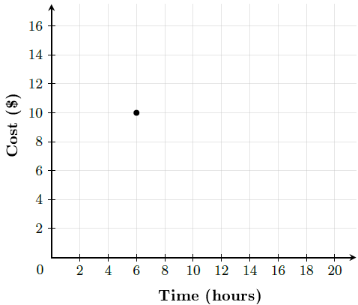
- What is the x-coordinate of the point shown?

6

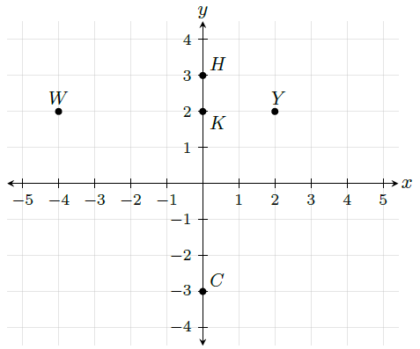
- Which point is the farthest away from point K?

C

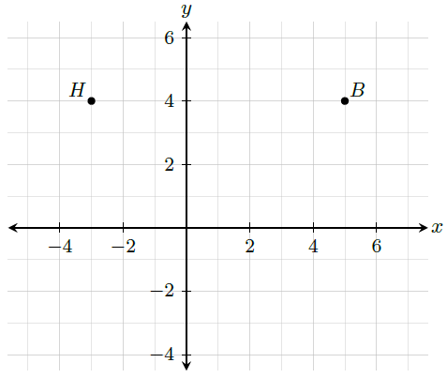
- How many units is point H from point B?

8

